Account Manager, Digital Creative Strategy
Job description
Our mission

To raise the bar in healthcare communications

Our vision

Virgo will be regarded as THE ‘must have’ healthcare communications consultancy partner

Our values

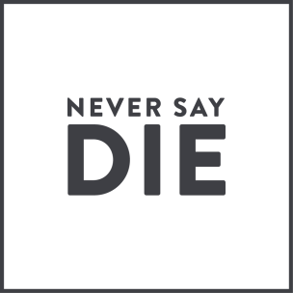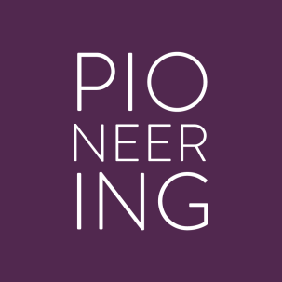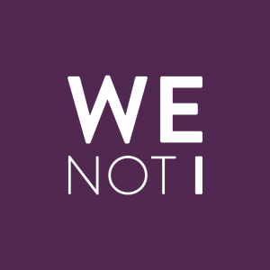

Job overview

This is an exciting opportunity for an ambitious individual with expert knowledge of how social and digital media works. The Account Manager, Digital Creative Strategy role will be responsible for executing social/digital media campaigns and research under the supervision of our Creative Digital Strategist. The ideal candidate will have gained their knowledge and experience from 2-3 years of agency experience (focussing exclusively on social and digital). A desire to learn more about healthcare communications and work in a heavily regulated/risk-averse environment is a must.

Core responsibilities and capabilities

Fee
Manager hat

- Assume ownership and accountability for your individual projects and your actions.
- Challenge yourself to contribute to the Agency business beyond the day-to-day responsibilities while maintaining excellence within your responsibilities.
- Take ownership of your career and seek out opportunities to learn from others inside and outside the Agency, both through mentoring and coaching relationships as well as active listening in day-to-day work.
- Confidently deliver information in a well-thought out and professional manner.
- Seek feedback and coaching from your supervisor and colleagues, turning it into meaningful and actionable direction to improve work product or individual performance.
- Pursue productive resolutions to manage conflict.
- In demanding situations, process, prioritize, develop a plan of action, deliver solutions and manage expectations.
- Look for opportunities to provide business-related ideas to your supervisor that help to solve business challenges.
- Coach and manage internal and external stakeholders.
Expert hat
Knowledge and skill

- Lead social/digital campaigns from conception to day-to-day live running.
- Craft and manage the execution of plans for small to medium-scale digital (social/influencer/paid) activations.
- Oversee updates to social platforms, sites and applications.
- Create, proofread and edit digital content as needed.
- Create reports that detail your digital activations.
- Quickly spot opportunities glean insights and brainstorm action plans.
- Demonstrate a working-knowledge of the client’s digital (social/influencer/paid) landscape.
- Develop and deliver client presentations related to digital (social/influencer/paid) activations.
- Initiate and contribute to strategic plans with some direction.
- Serve as an expert and project leader in your functional area.
- Actively listen to instructions and demonstrate an understanding of assignment expectations (timing and deliverables) seek out guidance when needed.
- Work well under pressure, remaining calm and professional.
- Maintain an up to date understanding of all digital competencies, including analytics, content creation, community management, website maintenance, influencer engagement and how earned/owned/paid media work together.
- Maintain basic knowledge of the Agency’s proprietary tools.
- Develop some level of expertise in one or more digital competencies.

Level of experience

- 2-3 years agency experience (agency speciality non-specific)
- Community management experience for 2+ years
- Content management & creation experience of 2+ years
- Social and digital listening/research experience Preferred not essential
- Client handling experience Preferred not essential

Skills and qualifications

Core skills

- Expert knowledge of backend of main platforms
- Working proficiency placing advertising spend
- Experienced brief creator (design studio)
- Knowledge of Adobe Suites (InDesign, Photoshop and Illustrator) Preferred not essential

Relationship building
- Foster and maintain strong relationships with Agency colleagues across communications, pharmacy (studio) and medical education communities and with clients through frequent and meaningful communication.
- Clearly, articulately and persuasively present to clients with direction.
- Build relationships with senior leaders and colleagues by flawlessly executing as directed on projects.
- Work proactively, demonstrating the ability to anticipate problems and opportunities; offer solutions to your team and supervisor that address business challenges.
- Ask thoughtful questions and demonstrate genuine curiosity and interest in Agency business (current and future initiatives, etc.).

Teamwork

- Provide training to others in specialised areas of expertise.
- Actively contribute to client and team meetings.
- Willingly accept new and challenging assignments and career opportunities.
- Foster a strong partnership with your community partners to develop the best ideas and programs for your clients and understand when and how to insure their involvement in the creative process.
- Earn trust and credibility with your internal partners as well as client counterparts.

Critical Thinking (creativity)

- Ability to identify online insights and trends.
- Understand how to turn analytics into insights.
- Monitor competitors and industry leaders to develop new types of content.
- Seek advice and counsel from internal team members when appropriate.
- Take initiative and demonstrate the ability to anticipate problems and opportunities:
- Think ahead and often have multiple solutions to potential challenges/problems.
- Analyse information and synthesize it into meaningful and actionable direction for team members.
- Recognize great ideas and working with stakeholders both internal and external.

Quality

- Exposure to budget requirements as it relates to media projects.
- Secure projected results through digital (social/influencer/paid) activations.
- Maintain accurate daily time entry.
- Manage and solve problems as it relates to the idea and creative development process.
- Assume responsibility and ownership for your work and that of interns you supervise.
- Effectively address the needs of your client and team in a thorough and timely manner.
- You have a strong knowledge of Agency processes and people, and demonstrate ability to navigate effectively.

Virgo behaviours

- Team player
- Passionate commitment
- Open communication
- Self-development
- Creatively curious
- Embracing change

